**An IoT and Cloud Based Real-Time Granary Monitoring and Alerting System Using LoRa Technology**

**1.Abstract:**

###### Granary environment management is critical for ensuring grain quality preservation and supply chain sustainability, aligning with the Sustainable Development Goal (SDG) 2 of Zero Hunger that addressing food security and ensuring access to safe, nutritious, and sufficient food for all. Traditionally, granary monitoring methods have relied on data communication technologies such as Bluetooth, WI-FI, GSM, GPRS, ZigBee, and others for data transfer. But, these technologies are limited to a short range of data transmission area. However, contemporary granaries demand innovative solutions that address real-time monitoring, impact mitigation, efficient communication technology, and early detection to eradicate hunger. The multifaceted impacts for grains, damages from various environmental factors to potential loss of grains, necessitate a proactive approach to protect them and ensure efficient precautions. This project introduces a system departing from fire or any unusual detection approaches by leveraging various sensors for swift identification of unusual activities. The system's effectiveness lies in its ability to monitor the granary in real-time. Strategically deployed sensors promptly capture fire detection, and through LoRaWAN communication, the acquired data is swiftly transmitted to a cloud-based platform for comprehensive analysis, contributing to global efforts to achieve Zero Hunger. Preventive measures and cautions are integral to granary management. By addressing hunger eradication, the proposed system aims to enhance overall food security by revolutionizing granary management practices. By leveraging innovative sensor technology and LoRaWAN communication, the system not only enables real-time monitoring but also facilitates early detection of potential threats to grain quality and safety.

###### 2.Introduction:

The IoT and Cloud-Based Real-Time Granary Monitoring System addresses challenges in traditional granary management. Granaries often lack real-time monitoring, leading to inefficiencies and grain quality risks. This system uses IoT and cloud technologies for real-time environmental monitoring, data analysis, and alerts. LoRa technology enables long-range wireless communication between sensor nodes and a central system without internet, ideal for remote granaries. Sensors like DHT11 (temperature/humidity), gas, soil moisture, and LDR (light) are connected to an ESP32 microcontroller, transmitting data via LoRa. The ESP32’s Wi-Fi forwards data to the cloud for analysis, allowing operators to make informed decisions and receive timely alerts for better grain management.

**3. Proposed Work:**

The system uses two architectures: Single Node and Overall Network. In the Single Node System, one node with sensors sends data to the LoRa receiver via a LoRa transmitter, providing centralized monitoring. The Overall Network System deploys multiple nodes in a granary, with each node collecting environmental data. Each node uses its own LoRa transmitter to relay data to a central LoRa receiver, which gathers and sends the information to the cloud through an ESP32 microcontroller. The cloud stores and analyses the data from all nodes across the granaries. This dual setup allows for focused monitoring with one node or broader coverage with multiple nodes, helping detect unusual activity in granary godowns.

**3.1. Working Methodology:**

The system integrates sensors like DHT11, MQ135, Soil moisture, and LDR with the ESP32 to collect real-time data on temperature, humidity, air quality, moisture content, and light intensity in the granary. Processed by the ESP32, the data is transmitted via LoRa to a receiver unit, then forwarded to a cloud-based platform via Wi-Fi. In the cloud, data is securely stored and analysed, empowering operators with insights to monitor conditions, detect anomalies, and make informed decisions.

**3.2 Block Diagram:**

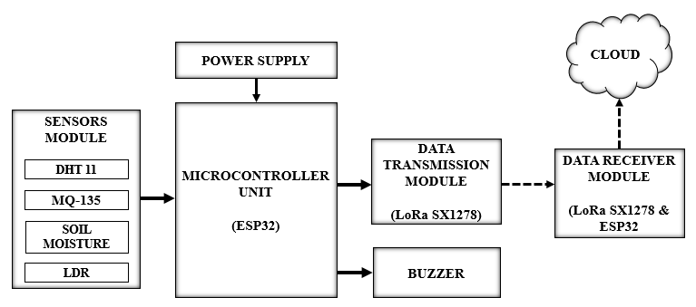

The block diagram outlines the complex architecture of the system featuring four essential blocks for precise granary environment data acquisition, processing, and real-time transmission. The Sensor Module integrates embedded sensors like the DHT11 (Temperature & Humidity) sensor, MQ-135 Air quality sensor, Soil moisture sensor, LDR (Light Dependent Resistor) operating in synergy to continuously monitor environmental conditions of granary. The ESP32 microcontroller serves as the central processing unit, handling real-time data from the Sensor Module and playing a vital role in decision-making and alert generation. The Data Transmission and Data Receiver Unit utilize the SX1278 LoRa module for seamless and reliable data transmission to the central LoRa receiver, employing the LoRaWAN protocol for optimal efficiency.

**3.3. Flow Diagram:**

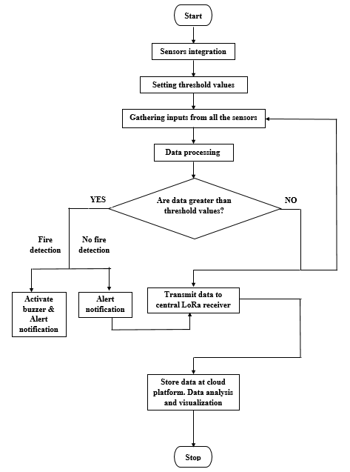

The operational sequence of the system unfolds with the provision of power to initiate the ESP32 microcontroller's functions. The integration of sensors with the MCU follows, each sensor utilizing its corresponding pins and drawing power for operation. These sensors continuously generate output values influenced by environmental conditions at the granary. To identify unusual events, specific threshold values are defined for each sensor, and their output data is systematically collected. The ESP32 microcontroller assumes the crucial role of processing this data, scrutinizing whether it surpasses the predefined threshold values. Upon detection of unusual activity exceeding the set thresholds, the system triggers an alert mechanism, activating a buzzer at fire conditions. Simultaneously, it transmits sensors’ real-time data, timely alert and notifications to the central LoRa receiver. This alert mechanism serves to notify farmers promptly, facilitating swift assistance to affected grains at the granary environment. Once the problem is resolved, the monitoring process ceases, and the accumulated data is securely stored in the cloud. In instances where the data does not exceed the predefined thresholds, it undergoes transmission to the central LoRa receiver for continuous monitoring. The data transmitted to the receiver is seamlessly stored in the cloud using the ESP32 microcontroller's built-in Wi-Fi functionality, thereby completing the comprehensive workflow of the earthquake monitoring system. This orchestrated process ensures timely and effective responses to unusual events, contributing to enhanced grains’ safety and risk mitigation in granary environments.

**3.4. Single Node System Architecture:**

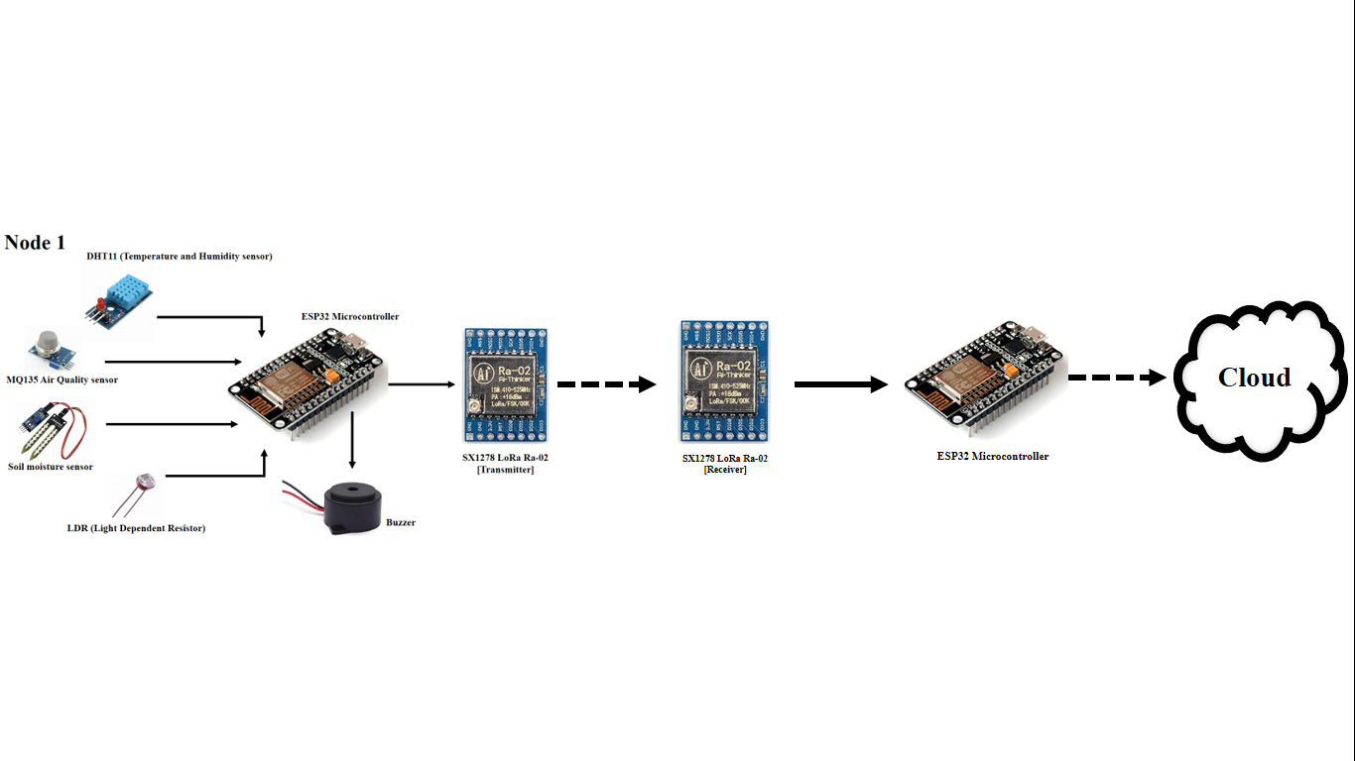

The Single Node System Architecture is depicted, showcasing a specific node that exemplifies the granary monitoring system's functionality. This node integrates sensors, including the DHT11 (Temperature & Humidity sensors), MQ-135 Air Quality sensor, Soil moisture sensor, LDR (Light Dependent Resistor). These sensors establish a cohesive network connected intricately to the ESP32 microcontroller for efficient data acquisition. The ESP32 processes the data comprehensively, employing a "threshold-based detection" mechanism to evaluate sensor values against predefined thresholds. If values fall below the threshold, the microcontroller retains the data; if they surpass the threshold, indicating any unusual event or fire detection, it triggers a buzzer for immediate audible notification and dispatches alerts accordingly. The LoRa advanced communication protocol ensures swift notification during abnormal conditions, with two LoRa modules facilitating seamless data transmission between sensors and the microcontroller. Collected data, including sensor values and alerts, is stored in the cloud via the ESP32 microcontroller, enabling in-depth analysis and data visualization for a comprehensive understanding of any abnormalities at granary.

**3.5. Overall Network Architecture:**

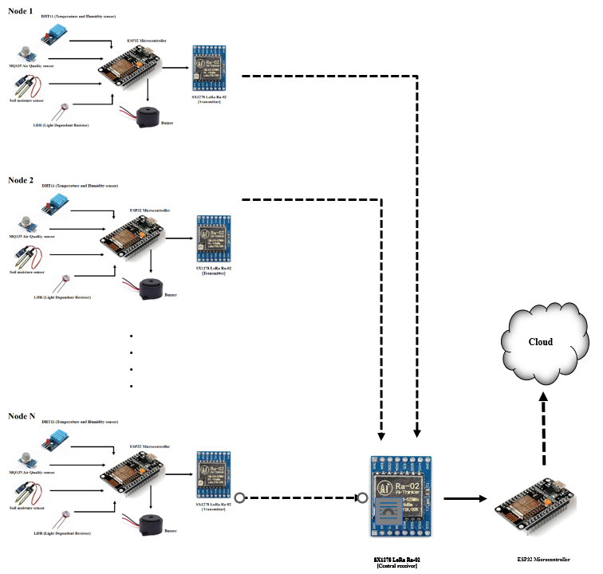

The Overall Network Architecture showcases the scalability of a granary monitoring system with multiple nodes across godowns. Each node, similar to the Single Node System, features sensors like DHT11 (temperature and humidity), MQ-135 (air quality), soil moisture sensor, and LDR (light intensity), all connected to an ESP32 microcontroller. These nodes operate independently, continuously monitoring and transmitting data to a central LoRa receiver via the LoRa communication protocol. The central receiver gathers data from all nodes and stores it in the cloud for centralized analysis and visualization, providing a comprehensive view of environmental conditions across granary godowns. Each node replicates the primary node (Node 1), which processes sensor data using the ESP32, triggers alerts via a buzzer, and uses a LoRa module for data transmission. LoRa modules ensure synchronized communication across nodes through time division multiplexing, enabling efficient data transfer to the central receiver. The cloud platform stores, organizes, and visualizes data through user-friendly dashboards, enhancing system performance. Key optimization strategies include sensor calibration, time division multiplexing, and threshold-based detection algorithms for real-time alerts. Continuous testing and sensor monitoring prevent false alarms and ensure system accuracy. Overall, this scalable network provides advanced, real-time granary monitoring, adaptable to diverse environments while ensuring reliability and responsiveness.

**4. Hardware Part:**

It explains the in-depth exploration of the physical components and devices integral to the proposed granary monitoring system, serving as a foundational reference for comprehending the technological framework underpinning its operations. By delineating the hardware components and their specific functions, readers are equipped with a comprehensive understanding of the system's architecture and operational intricacies. From sensors responsible for capturing environmental data to actuators facilitating control actions, each hardware element contributes significantly to enabling real-time monitoring and management of grain storage conditions. The detailed overview elucidates the critical role played by communication terminals and controllers in facilitating seamless data exchange and system coordination, underscoring their importance in ensuring the system's efficiency and reliability. Through this comprehensive examination of physical components, the chapter elucidates the interconnectedness and synergy inherent in the system's hardware infrastructure, laying the groundwork for subsequent discussions. The grain storage monitoring system utilizes a range of hardware components for comprehensive surveillance. This includes the DHT11 Temperature and Humidity sensor, MQ135 Air quality sensor, Soil moisture sensor, LDR Light Dependent Resistor, and a Buzzer for alerts. The ESP32 Microcontroller acts as the central processing unit, coordinating data collection and actuation responses. Long-range communication is facilitated by the SX1278 LoRa Ra-02 module. Together, these components enable real-time monitoring and intervention to ensure grain quality and prevent spoilage.

**4.1. Transmitter Unit:**

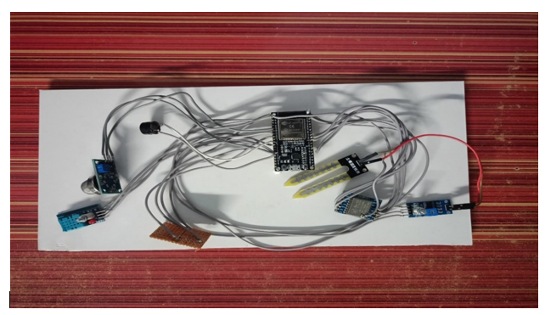

The transmitter unit forms the backbone of the monitoring system, housing an array of essential sensors including the DHT11, MQ135, Soil moisture sensor, and LDR, all seamlessly integrated with the versatile ESP32 microcontroller. Once powered, these sensors diligently collect data from the granary environment, ensuring a continuous stream of crucial information. The microcontroller meticulously processes this data, refining it into actionable insights before transmitting it to the central LoRa transmitter.

**4.2. Receiver Unit:**

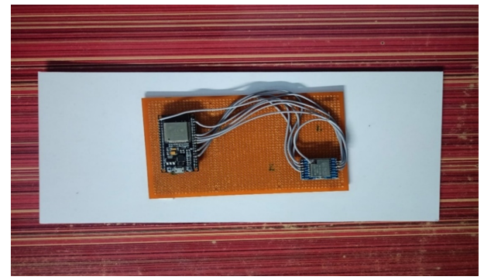

The receiver unit is the linchpin in the data retrieval process, boasting a LoRa receiver that seamlessly captures data transmitted from the LoRa transmitter. Upon reception, the ESP32 microcontroller steps into action, diligently processing the incoming data streams with precision and efficiency. Once processed, this valuable data is swiftly dispatched to the cloud-based platform, where it is stored securely for subsequent analysis and visualization.

**5. Software Part:**

This part explores the software architecture of the grain storage monitoring system, highlighting its role in data acquisition, processing, visualization, and remote management. It delves into how intelligent algorithms and intuitive user interfaces work together to provide users with actionable insights and real-time control over grain storage conditions. The software description covers the design of user-friendly interfaces and advanced data analytics algorithms, demonstrating how they enhance system performance, reliability, and scalability. Ubidots IoT cloud is emphasized as a key platform, offering a versatile solution for connecting, visualizing, and analyzing data from IoT devices. Its user-friendly interface and scalable architecture make IoT data management simple, enabling real-time sensor data collection and visualization. Ubidots also integrates with third-party services, allowing developers to build powerful IoT solutions. Additionally, the chapter introduces the Arduino Integrated Development Environment (IDE), which simplifies the programming of Arduino-based projects, making it accessible for both beginners and experienced developers to create and upload code easily, bridging the gap between hardware and software.

**5.1. Transmitter Program Setup in Arduino IDE:**

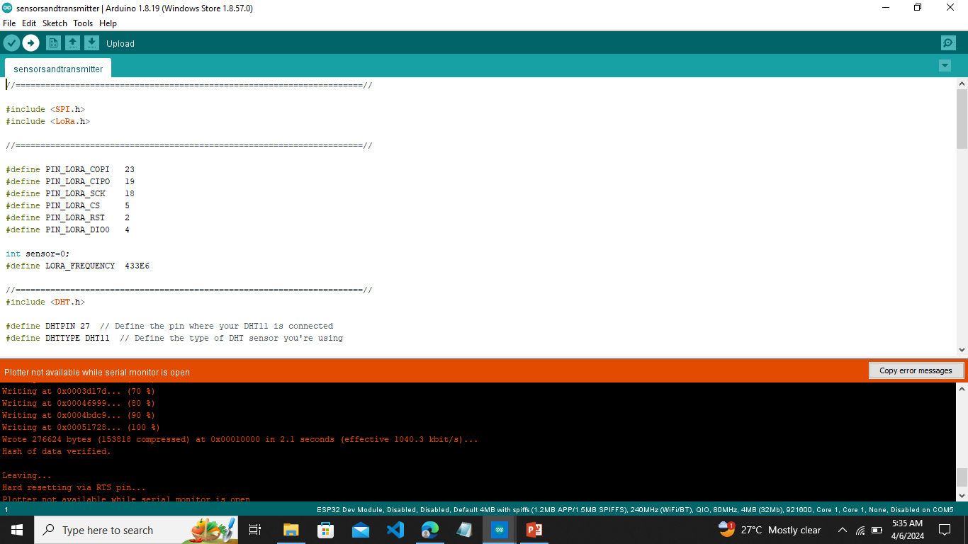

This setup encompasses the meticulous configuration of code and parameters necessary to orchestrate the seamless functioning of the transmitter unit. Within the Arduino IDE, various modules and libraries are integrated and initialized to ensure optimal performance and compatibility with the hardware components comprising the transmitter unit. Through this program setup, the transmitter unit is equipped to execute its designated tasks, including sensor data acquisition, processing, and transmission via LoRa communication protocols.

**5.2 Receiver Program Setup in Arduino IDE:**

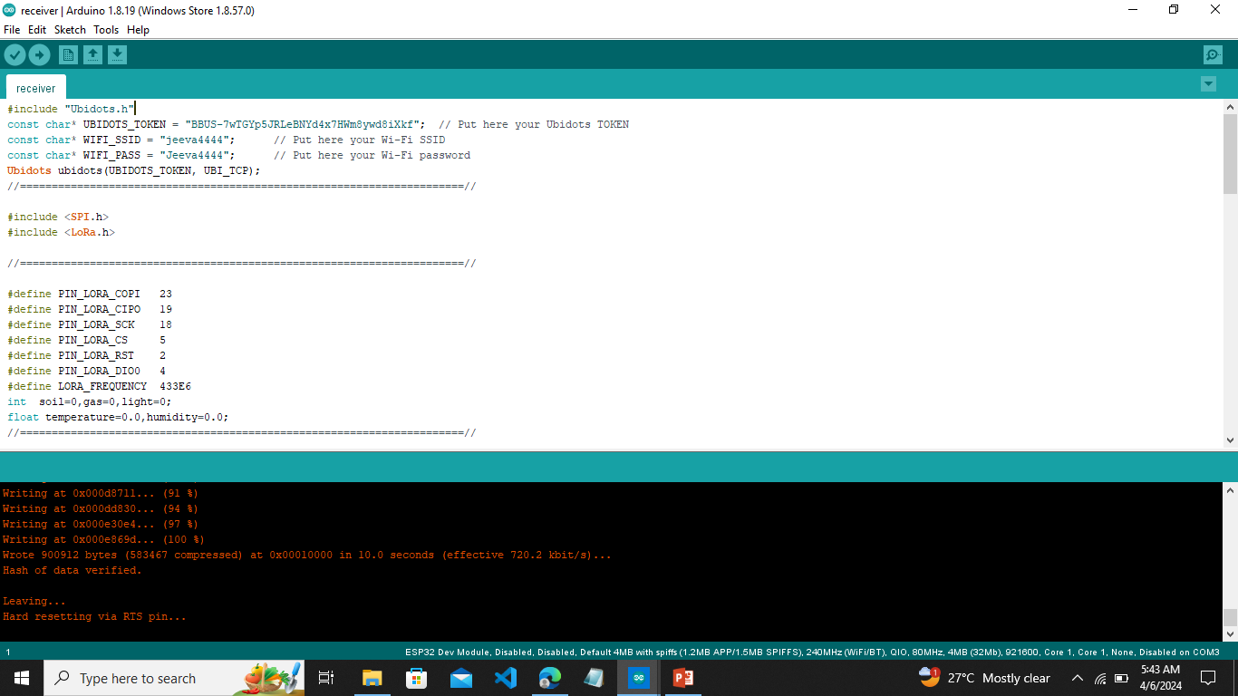

This comprehensive setup encompasses the configuration of code and parameters necessary to facilitate the seamless operation of the receiver unit. Within the Arduino IDE, various modules, libraries are integrated and initialized to ensure optimal performance and compatibility. Through this program setup, the receiver unit is equipped to execute its designated tasks.

**6. Overall Implementations:**

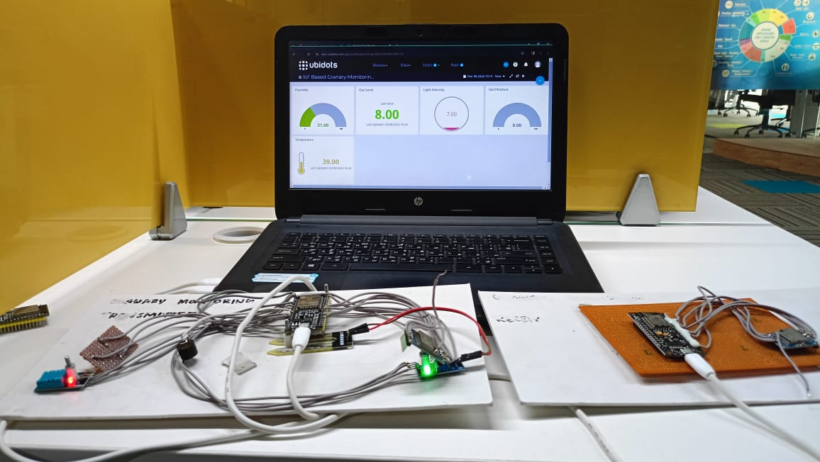

The comprehensive implementation of An IoT and Cloud Based Real-Time Granary Monitoring and Alerting System Using LoRa Technology involves the integration of various hardware components and cutting-edge technologies. The sensor module, consisting of the DHT11 (Temperature and Humidity sensor), MQ135 Air quality sensor, Soil moisture sensor, and LDR (Light Dependent Resistor), is intricately connected to the ESP32 microcontroller, forming the foundation of the system. Additionally, a buzzer is seamlessly integrated to provide real-time audible notifications during fire detection. The LoRa communication setup employs the SX1278 LoRa module for efficient long-range wireless communication, linking the LoRa transmitter to the ESP32 at the transmitter side and the LoRa receiver at the receiver side, enabling data transmission to the central LoRa receiver. Software development utilizing the Arduino IDE (version 1.8.19) focuses on real-time data processing, implementing a threshold-based detection mechanism, and activating the buzzer in response to fire detection. Configuration of LoRaWAN communication protocols ensures seamless and reliable data transmission. Cloud integration involves establishing an IoT cloud platform, leveraging platforms like Ubidots Cloud, to serve as a centralized repository for collecting, storing, organizing, analyzing, and visualizing the data. Rigorous testing, including test analysis on granary environmental factors, validates the system's performance, ensuring accuracy under abnormal conditions at granary godowns.

**7. Results:**

**7.1. Serial monitor data visualization in Arduino IDE:**

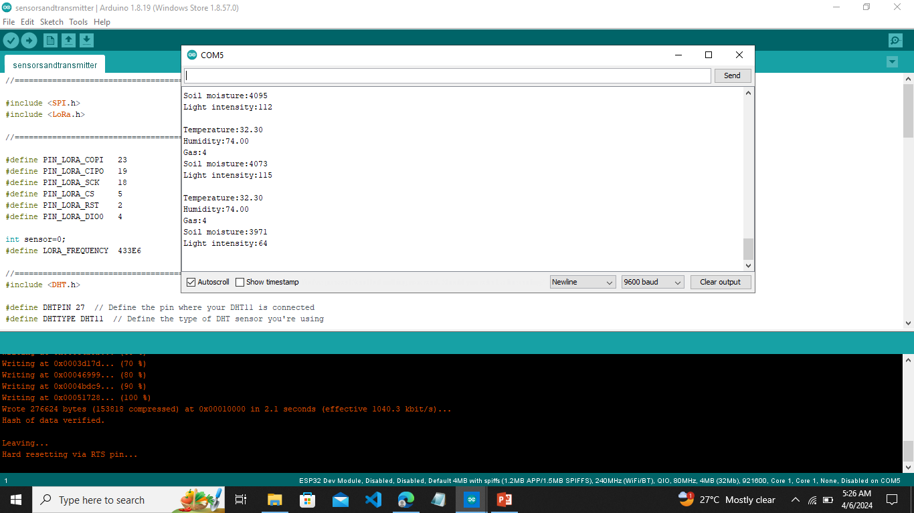

This visualization tool provides real-time insight into the data transmission and reception process, allowing users to monitor the exchange of information between the transmitter and receiver units. Following the uploading, compiling, and execution of the program, users can observe the transmitted data in the transmitter program's serial monitor, while simultaneously monitoring the received data in the receiver program's serial monitor. The primary objective of this visualization is to verify the accuracy and integrity of the transmitted data upon reception, ensuring seamless communication between the transmitter and receiver units. By scrutinizing the data displayed in both serial monitor windows, users can ascertain whether the transmitted data is successfully received at the receiver end, thereby validating the effectiveness of the communication protocol and system setup.

**7.2 Cloud data visualization in Ubidots IoT Cloud:**

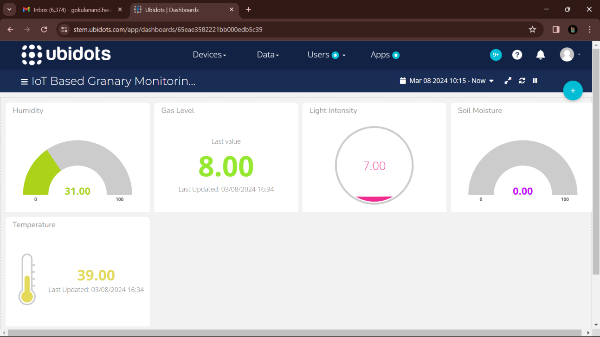

The Cloud data visualization in Ubidots IoT cloud, shows some real-time example data about the granary environmental parameters. Once the collected data is successfully stored on the cloud server, users gain access to a comprehensive platform for monitoring and analyzing the data. The cloud continuously stores the incoming data, ensuring that users have access to up-to-date information regarding granary conditions. Leveraging a user-friendly dashboard, stakeholders can effortlessly visualize the stored data, facilitating insightful analysis and decision-making. The Ubidots IoT cloud boasts an array of features that enhance data visualization, making it an attractive tool for granary management. In addition to storing, analyzing, and visualizing data, the platform offers the functionality to set threshold values for each monitored parameter. This capability enables users to define optimal ranges for temperature, humidity, air quality, and other critical factors, empowering proactive monitoring and intervention. Furthermore, the platform's alert notification features, including email and SMS alerts, ensure timely dissemination of critical information to farmers and granary operators. By receiving alert notifications, users can promptly respond to deviations from optimal conditions, implementing corrective actions to safeguard grain quality.

**8. Conclusion and Future Scope:**

The successful implementation of this project paves the way for numerous future enhancements, promising to further transform granary management and agricultural storage systems. One key area for development is the integration of advanced algorithms and predictive analytics into the monitoring system, enabling early detection of potential environmental risks and automated adjustments to prevent spoilage. Incorporating advanced sensor technologies can provide more precise monitoring of grain quality, including nutritional content and contamination. The system's scalability offers potential for widespread use across various agricultural settings, from small farms to large-scale storage facilities, enhancing food security and economic resilience. Collaborations with industry and research institutions can refine and adapt the system to different climates, grain types, and storage infrastructures. Additionally, developing user-friendly interfaces and mobile applications can empower operators with intuitive tools for remote monitoring, decision support, and real-time alerts, improving accessibility and ease of use. By leveraging emerging technologies, the system can enhance transparency and traceability in grain supply chains, increasing market competitiveness. Partnerships with government agencies and international organizations can promote knowledge exchange, capacity building, and policy advocacy to encourage the widespread adoption of advanced monitoring systems and sustainable storage practices. Ultimately, the future scope of the project involves a multifaceted approach to improving agricultural storage, integrating innovation, collaboration, and technology to meet evolving global food system challenges.